mMUSIC ANDROID APPLICATION

Software Requirements Specification

Version 1.0

Class Name | Android Mobile Programming
Class Code | Android k16
Group | mMusic K16 Group
Teacher | Khanh Nguyen
Project Manager | Khanh Nguyen
Assign Date | 10/10/2011
Complete Date | 10/24/2011
Author | mMusic K16 Group
Version | 1.0
Approved By
Approved Date

Table of Contents
1. Introduction 4
1.1 Purpose 4
1.2 Scope 4
1.3 Definitions, Acronyms and Abbreviations 4
1.4 References 4
2. OVERAL Description 4
2.1 Product Perspective 4
2.2 Product Features 4
2.3 User Documents 4
2.4 Assumptions 5
2.5 Constraints 5
3. Use case model 5
3.1 The Actors 5
3.2 The use cases 5
3.3 Use cases diagram 7
4. Functional Requirements 7
4.1 Feature Manage Playlist 7
4.1.1 Use case Add Playlist _ UC-001 7
4.1.2 Use case Delete Playlist _ UC-002 8
4.1.3 Use case Rename Playlist _ UC-003 8
4.1.4 Use case Edit Playlist _ UC-004 8
4.1.5 Use case Browse Playlist _ UC-005 9
4.1.6 Use case Edit Song _ UC-006 9
4.1.7 Use case Add Song _ UC-007 10
4.1.8 Use case Remove Song _ UC-008 10
4.1.9 Use case Sorting Song _ UC-009 11
4.1.10 Use case Search Song in Playlist _ UC-010 11
4.1.11 Use case Play Song in Playlist_ UC-011 12
4.2 Feature Artist and Album 12
4.2.1 Use case Browse artists_ UC-012 12
4.2.2 Use case Browse Songs of an Artist _ UC_013 13
4.2.3 Use case Play Song of an Artist _ UC_014 13
4.2.4 Use case Search Artist _ UC-015 13
4.2.5 Use case Search Song of Artist_ UC-016 14
4.2.6 Use case Browse Albums _ UC-017 14
4.2.7 Use case Search Albums_ UC-018 15
4.2.8 Use case Browse Song of Album_ UC-019 15
4.2.9 Use case Search Song of Album_ UC-020 16
4.2.10 Use case Play Song in Album_UC-021 16
4.3 Feature List Song and Playlist 16
4.3.1 Use case Browse List of Song_ UC-022 16
4.3.2 Use case Playback Control_ UC-023 17
4.3.3 Use case Previous_ UC-024 17
4.3.4 Use case Next_ UC-025 18
4.3.5 Use case Play/Pause_ UC-026 18
4.3.6 Use case Stop_ UC-027 19
5. Non-Functional Requirements 19
5.1 Usability 19
5.2 Reliability 19
5.3 Performance 20
5.4 Supportability 20
6. Conclusion 20

Introduction

Purpose
This SRS Document contains the complete software requirements for the mMusic application and describes the design decisions, architectural design and the details design needed to implement the application. It provides the visibility in the design and provides information needed for the application support.

Scope
mMusic application is developing for Android Environment(AE) and use to replace the initial application. mMusic application is to build upon the AE in order to implement all of the process and friendly for users.

Definitions, Acronyms and Abbreviations
Term | Definitions, Acronyms and Abbreviations
mMusic | Mobile Music
AE | Android Environment
SRS | Software Requirements Specification
GU | Graphic User Interface
UC | User Case
MTBF | Mean Time Between Failures

References
Android Application Fundamentals from: http://developer.android.com/guide/topics/fundamentals.html

OVERAL Description

Product Perspective
- It will be one of the best android music player
- This is the software which beautiful GUI, support many function

Product Features
- Support a lot of type of music.
- Repeat, Shuffle.
- Show lyrics in playing.
- Can play in background.
- Can play music by name of song, artist, and album.

User Documents
<Help>
- How to delete playlist
- How to edit (add/remove) song in playlist
- How to choose the state of playing music (repeat/shuffle)

Assumptions
- Only run on android 2.1 or higher
- Hardware configuration:
- CPU 1ghz
- RAM 128MB

Constraints
- Using Android Phone such as HTC, Nexus, and Samsung…
- Running on Android 2.1 or higher.

Use case model

The Actors
- User: The user represents any person who will be using the music player.

The use cases

System Features | Main Use Case | Use Case ID
 | Add Playlist | UC-01
 | Delete Playlist | UC-02
 | Rename Playlist | UC-03
 | Manage song in list Artist | UC-04
 | Manage song in list Album | UC-05
 | Add Song | UC-06
 | Remove Song | UC-07
 | Previous | UC-08
 | Next | UC-09
 | Play/Pause | UC-010
 | Stop | UC-011

Use cases diagram
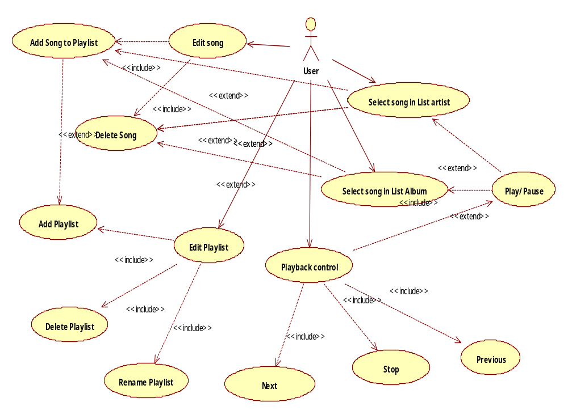

Functional Requirements

Feature Manage Playlist

Use case Add Playlist _ UC-01
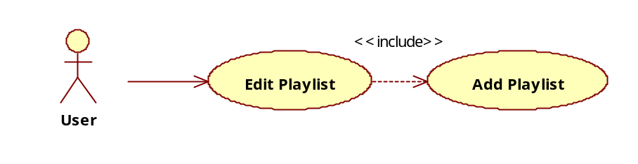
Use Case ID | UC-01
Name | Add Playlist
Goal | The user wants to add a new playlist.
Actors | User.
Include | None.
Extended | None.
Pre-conditions | - Application Start  - User is standing on the screen of the playlist
Post-conditions | A new playlist is saved successfully.
Main Flow | - User touch and hold until the function Add playlist appear  - User choose the add playlist function  - Enter the name of the playlisy  - Save
Exceptions | The playlist’s name have been already exist
Open Issues | None.

Use case Delete Playlist _ UC-02
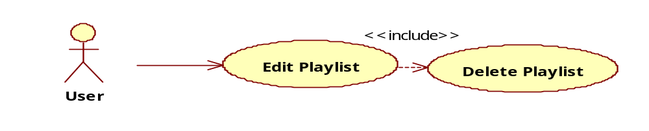
Use Case ID | UC-02
Name | Delete Playlist
Goal | The user wants to delete a playlist.
Actors | User.
Include | None.
Extended | None.
Pre-conditions | - Application Start  - User is standing on the screen of the playlist.
Post-conditions | A playlist is deleted successfully.
Main Flow | - User touch on the playlist and hold until the function delete playlist appear  - User choose the delete playlist function
Exceptions | The user cannot delete playlist, which has currently playing the song.
Open Issues | None.

Use case Rename Playlist _ UC-03
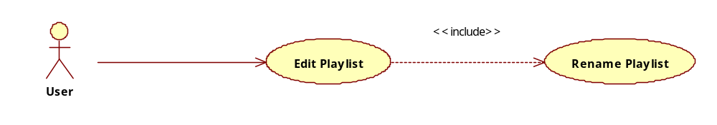
Use Case ID | UC-03
Name | Rename Playlist
Goal | The user wants to change playlist’s name.
Actors | User.
Include | None.
Extended | None.
Pre-conditions | - Application Start  - User is standing on the screen of the playlist.
Post-conditions | Playlist has a new name.
Main Flow | - User touch and hold until the function rename playlist appear  - User choose the rename playlist function  - Enter the name for the playlist  - Save
Exceptions | The user cannot rename playlist, which has currently playing the song.  The name have already exist
Open Issues | None.

Use case Manage song in list Artist_UC-04

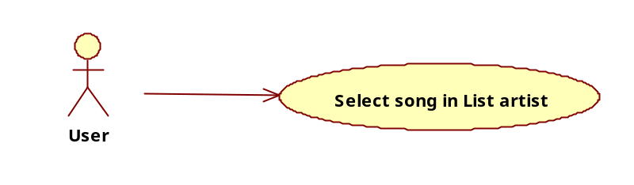
Use Case ID | UC-04
Name | Select song in List Artist
Goal | User can do some action with the song such as:  - Play  - Delete  - Add to playlist
Actors | User.
Include | None.
Extended | None.
Pre-conditions | - The user is standing at the list Artist view
Post-conditions
Main Flow | - Touch and hold until these function appear:  - Play  - Delete  - Add to playlist  - Choose the function
Exceptions
Open Issues | None.

Use case Manage Song in list Album-UC-05
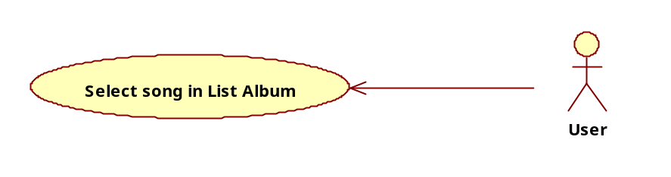

Use Case ID | UC-05
Name | Select song in List Album
Goal | User can do some action with the song such as:  - Play  - Delete  - Add to playlist
Actors | User.
Include | None.
Extended | None.
Pre-conditions | - The user is standing at the list Album view
Post-conditions
Main Flow | - Touch and hold until these function appear:  - Play  - Delete  - Add to playlist  - Choose the function
Exceptions
Open Issues | None.

Use case Add Song to Playlist _ UC-06
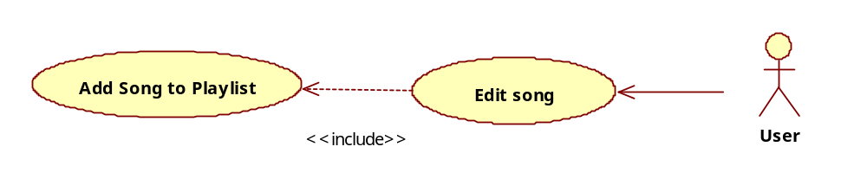
Use Case ID | UC-06
Name | Add Song
Goal | The user wants to add songs in playlist.
Actors | User.
Include | None.
Extended | None.
Pre-conditions | Application start
Post-conditions | The user adds songs into playlist successfully.
Main Flow | - Touch and hold the song that he want to add  - Choose add to play list function  - Choose the playlist to be added or create new play list  - OK
Exceptions | None.
Open Issues | None.

Use case Remove Song _ UC-07
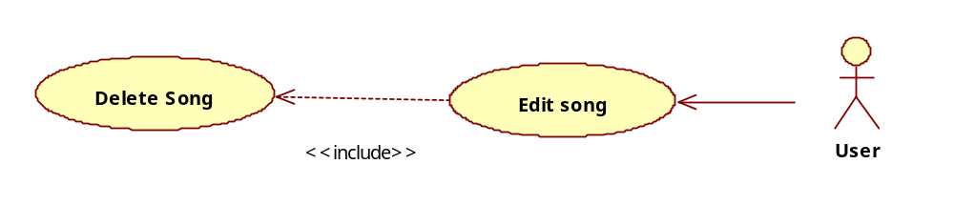
Use Case ID | UC-07
Name | Remove Song
Goal | The user wants to remove song.
Actors | User.
Include | None.
Extended | None.
Pre-conditions | - Application Start
Post-conditions | The user removes the song successfully.
Main Flow | - Touch and hold the song the he want to delete until delete function appear  - Choose delete function  - Ok
Exceptions | The user cannot delete a song from a playlist that is currently playing the song.
Open Issues | None.

Use case Previous_ UC-08
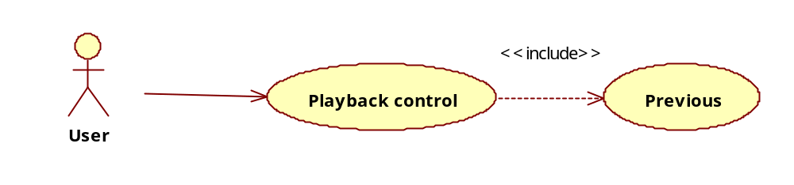
Use Case ID | UC-08
Name | Previous
Goal | User want to back the previous song
Actors | User.
Include | None.
Extended | None.
Pre-conditions | - The user has the music player open.  - Player is playing a song.  .
Post-conditions | Song is played to previous song successfully.
Main Flow | - The user selects which “Previous” button on the screen he wants to perform, and then the current playing song will change to previous song.
Exceptions | None.
Open Issues | None.

Use case Next_ UC-09
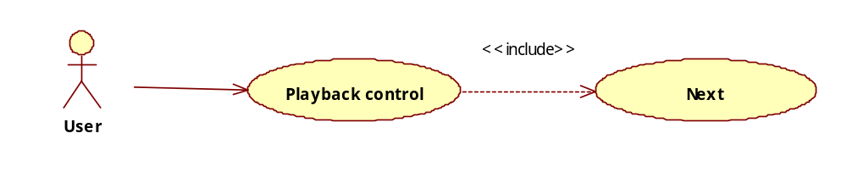
Use Case ID | UC-09
Name | Next
Goal | The user wants to listen to next currently playing song.
Actors | User.
Include | None.
Extended | None.
Pre-conditions | - The user has the music player open.  - Player is playing a song.  - The user knows which playback action he wants to perform.
Post-conditions | Song is played to next song successfully.
Main Flow | - The user selects which “Next” button on the screen he wants to perform, and then the current playing song will change to next song.
Exceptions | None.
Open Issues | None.

Use case Play/Pause_ UC-010
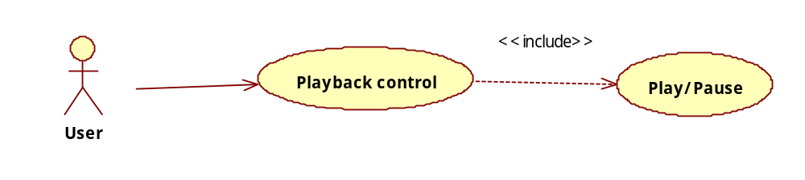
Use Case ID | UC-010
Name | Play/Pause
Goal | The user wants to play and pause a song.
Actors | User.
Include | None.
Extended | None.
Pre-conditions | - The user has the music player open.  - Player is playing a song.  - The user knows which playback action he wants to perform.
Post-conditions | The user plays or pause song successfully
Main Flow | - The user selects the song he likes to listen.  - The user presses “Play/Pause” button to play a song, or stop a song at a position time in playing current.
Exceptions | None.
Open Issues | None.

Use case Stop_ UC-011
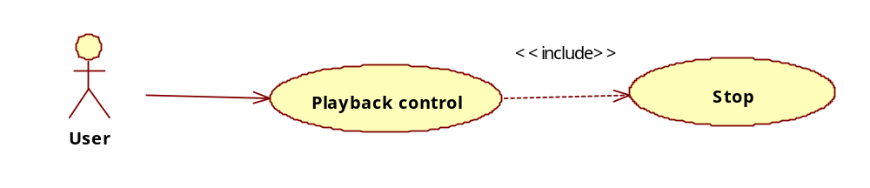
Use Case ID | UC-011
Name | Stop.
Goal | The user does not want to continue to listen to music anymore.
Actors | User.
Include | None.
Extended | None.
Pre-conditions | - The user has the music player open.  - Player is playing a song.  - The user knows which playback action he wants to perform.
Post-conditions | The user stops the playing song successfully.
Main Flow | - The user presses “Stop” button to stop playing a song, and the position time in playing current will back to first time.
Exceptions | None.
Open Issues | None.

Non-Functional Requirements

Usability
- Ease of use requirement:
The mMusic should have an easily understandable design in order for users to use it. It should provide the necessary information when the user commits possible errors. It should indicate the several possibilities that the user has to go on in using the mMusic. The user will always be asked to double-check their choice in case they misunderstood the option or clicked on a button by accident. The system will have easy access to help center whenever the user needs any kind of assistance.

- Learning requirement:
It should not require a massive amount of time learning how to use the system. In fact, our goal is to create a self-explanatory system that does not ideally need any tutorial section. Besides that, we support to user a manual in “Help” which will show step-by-step in our mMusic.

- Understandability requirement:
The mMusic is designed following simple way and not complex. We will help user approach to it easily with friendly interface. The whole word utilized and used is supposed to be at least familiar if not completely acknowledged by the user.
\

Reliability
- Availability: The system shall be available all the time
- Mean Time Between Failures (MTBF): shall exceed 3 months.

Performance
- Speed:
The mMusic can play smoothly all android phones at least on Android 2.1 or higher.

- Robustness requirement:
When the mMusic is played next or previous song by clicking many times continuously, it makes application frozen. It will stop working and also save last song which user has being used.

- Capacity requirement:
The mMusic should be able to manage all songs with many formats incoming on SDcard.

Supportability
- Configurability
    - Android OS 2.1 or higher
    - CPU: Qualcomm MSM 7225
    - 128 MB RAM; 256 MB ROM
    - Micro SD support
- Testability: as least bugs as possible, run smoothly on Android OS 2.1 or higher.
- Adaptability: easy to use, can hear music or record track, hear right songs want to play.
- Design constraints: friendly interface, simple interface, easy to understand, eco-friendly.
- Install ability: fast and easy.

Conclusion
- The mMusic is one of the best music player run on android, support full function, professional graphic user interface. We also provide it to all users free.
- In the future, we are going look forward to receiving your contributions for the product, so we can improve our products to satisfy the users' expectations.

---------- End of Document ----------

